**Business Profile Description of Realiza Entrepreneurs**

**REALIZA Program**

***Maio de 2022***

Acknowledgments

The document xxxxxxxxxxxxxxxxxxxxxxxxxxxxxx

Summary

Acknowledgments 2

Summary 3

Introduction 4

1. Mobilization Process for the REALIZA Program 5

What was done during the mobilization process for the REALIZA Program 5

Main challenges and main learnings from the mobilization processs 5

2. Description of the business profile of the candidates entrepreneurs 5

3. Description of the business profile of selected entrepreneurs 9

4. Candidates and selected entrepreneur’s 13

5. Key strategic considerations for future mobilization 13

Introduction

The objectives of the following report are:

1. Describe the profiles of female entrepreneurs mobilized for the REALIZA Program in order to understand which profiles expressed interest in enrolling in the program during the mobilization period;
2. Identify whether there are new strategies that can be used to mobilize the profile idealized for the REALIZA Program based on the data available.
3. Mobilization Process for the REALIZA Program

## What was done during the mobilization process for the REALIZA Program

Xxxxxxxxxxxxxxxxxxxxxxxxxxxxxxxxxxxxxxxxxxxx

## Main challenges and main learnings from the mobilization processs

1. Description of the business profile of the candidates entrepreneurs

The data presented below refers to….Xxxxxxxxxxxxxxxxxxxxxxxxxxxxxx

**Business context**

The mobilization process reached 6003 entrepreneurs in the three cities, which 89 were not actually business owners.

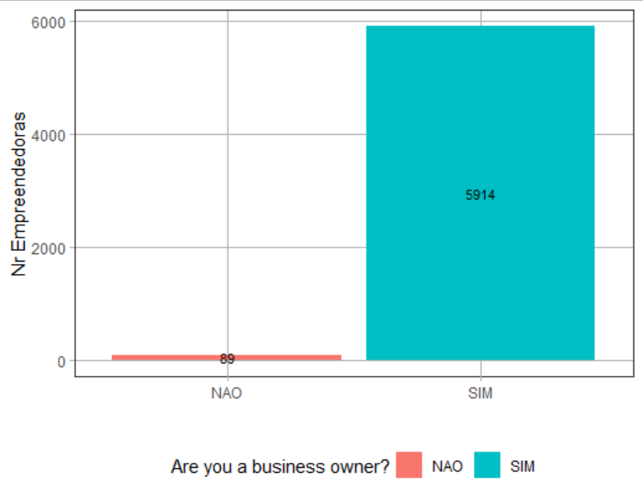 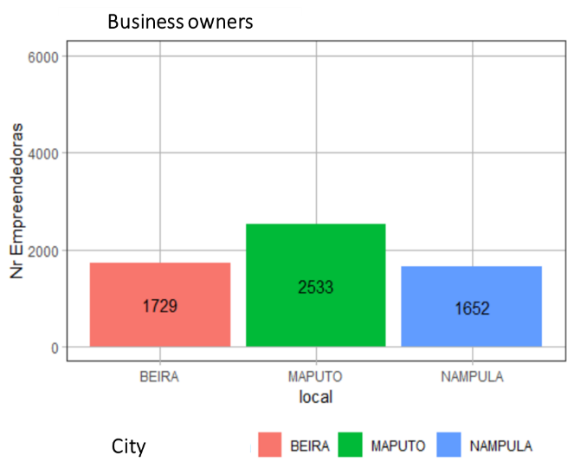

From the 5914 mobilized entrepreneurs, were 2533 from Maputo, 1729 from Beira, 1652 from Nampula.

**Business formalization**

As for the business profile of the entrepreneurs mobilized for the Realiza Program, it is noted that the vast majority of businesses are not formalized in the three cities. In the city of Maputo, 12.4% of entrepreneurs have formally registered businesses, in the city of Nampula 11.9% have formally registered businesses and in the city of Beira we noticed the smaller number of formalized businesses, with only 9.7%.

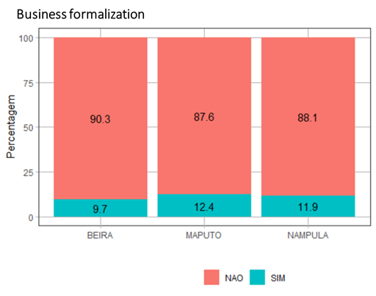

**Profit from business**

In the three cities, the majority of female entrepreneurs made less than five thousand meticais in profit in the last month prior to their registration for the Realiza Program. Maputo is the city that shows the largest number of female entrepreneurs making more profit, with 13.6% of entrepreneurs making more than ten thousand meticais and 22.1% makinf from five to ten thousand meticais. In the city of Nampula and Beira there are similar numbers of female entrepreneurs who make more than ten thousand meticais in profit, 9% in Beira and 8.7% in Nampula, however, the city of Beira has a range of 26.9% female entrepreneurs who make between five and ten thousand meticais in profit, while in Nampula 14.6% are in this range.

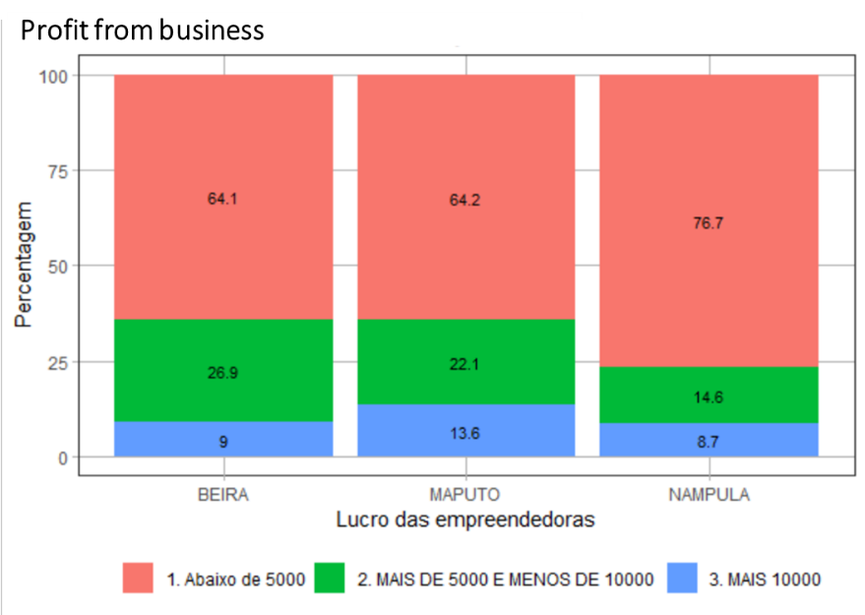

**Formalization through business time of existence**

Formalized businesses are usually from entrepreneurs who have been implementing the business for a longer time in the market, from 2 to 8 years with an average of 4 years of business existence. The unregistered businesses are from entrepreneurs who implement the business for less time, from 2 to 6 years, with an average of 3 years. It was identified that the greater the profit, the greater the chance of the business being formalized.

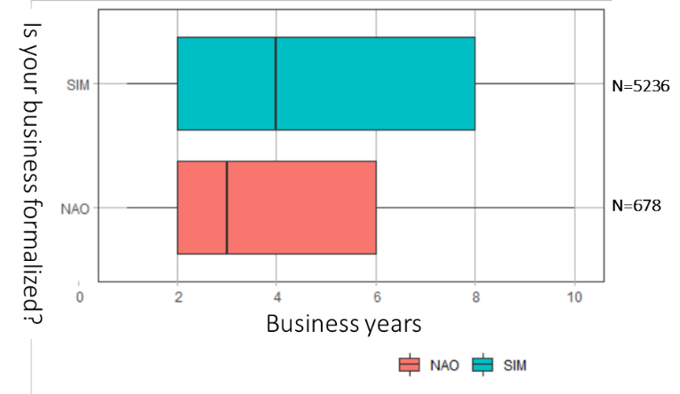

**Business time of existence and profit**

According to the data, the years of experience of a business seem to contribute to the greater acquisition of profits. The most profitable business are the ones with more time of existence, while the most recent businesses are the ones that made the smallest profit.

Businesses that made more than ten thousand meticais of profit were the ones between 3 to 9 years of existence with an average of 4 years.

The businesses with that made less than five thousand meticais of profit were the ones

with 2 to 5 years of existence, with an average of 3 years.

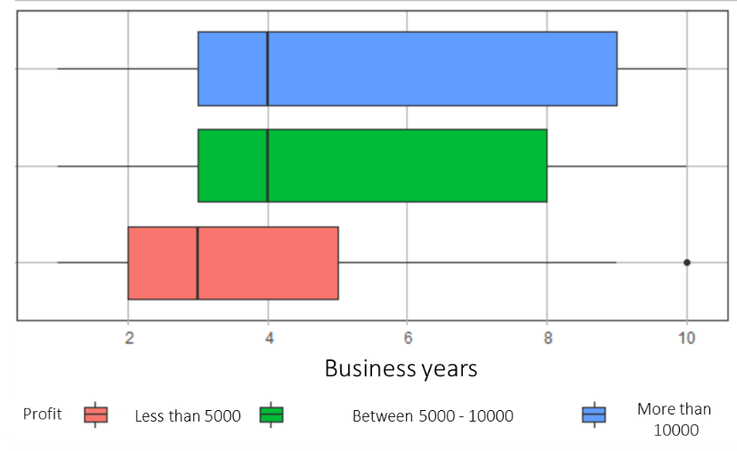

**Workers and profit**

The entrepreneurs who signed up for the Realiza Program were asked whether in the last month their businesses had any type of workers (wage workers or not, working full-time or part-time). This data was cross-referenced with the profit made in their business in the past month and is shown in the following chart:

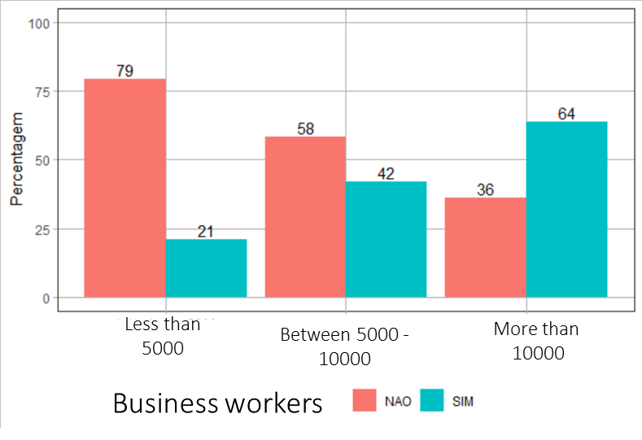

The businesses that made the lowest profit (less than five thousand meticais), 79% of them do not had workers. While those businesses that profited more (more than ten thousand meticais) had workers, with 64% of them with workers. The businesses that made between five and ten thousand meticais of profit, 58% of them do not have workers and 42% do.

**Social Media and Profit**

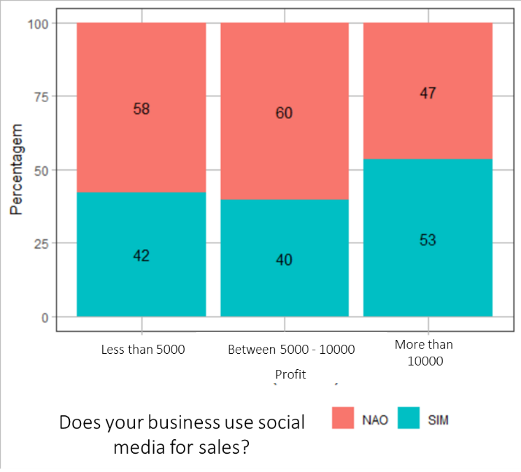

1. Description of the business profile of selected entrepreneurs

Selection criteria were applied to the candidates with the hypothesis that they would lead to a profile of entrepreneurs with more structured businesses. At the same time, there was a concern to make the program inclusive for different profiles of entrepreneurs. Registered businesses were immediately selected. If it wasn’t registered the business should have at least two of the following criteria to be selected:

1. At least two years of business existence
2. To make more than 10,000 meticais of profit in the last month of operation
3. At least one worker in the businesses (salaried or not)

Considering these criteria, from the number of 5914, 2038 entrepreneurs were selected from the three cities as shown in the graphic bellow:

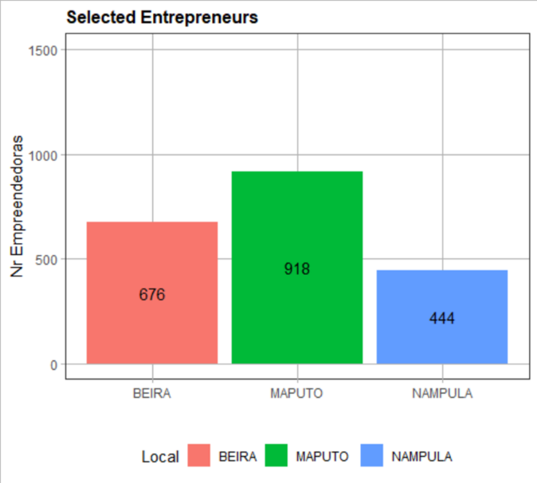

918 businesses from the city of Maputo, 67 form Beira and 444 from Nampula.

The chart below shows the composition of business profiles according to the selection criteria. The data show that most entrepreneurs were selected by the criteria related to business time of existence and for having workers (salaried or not).

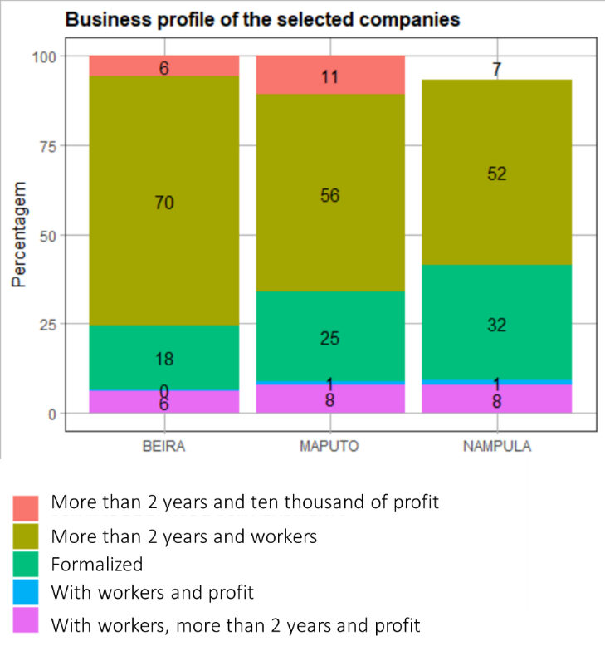

From the selected entrepreneurs, 32% in Nampula have registered business, while 25% in Maputo and 18% in Beira.

**Profit from Business**

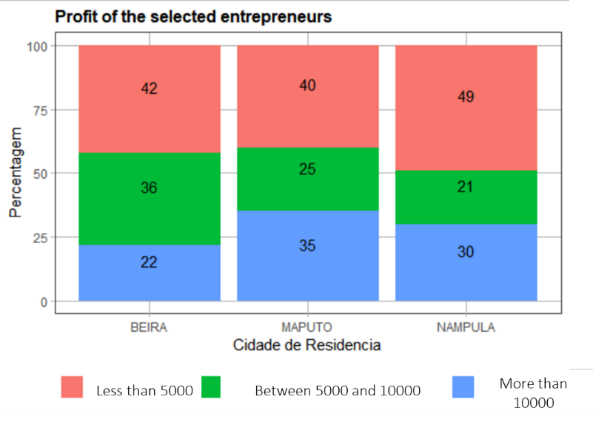

Like the Realiza Program candidates mobilized, the majority of the selected female entrepreneurs made less than five thousand meticais in profit in the last month prior to their registration in the Program. Maputo is the city that shows the largest number of female entrepreneurs making more profit, with 35% of entrepreneurs making more than ten thousand meticais and 25% making from five to ten thousand meticais. In the city of Nampula 30% of entrepreneurs made more than ten thousand meticais in profit and in Beira 22% of them.

**Formalization through business time of existence**

It is interesting to note that differently from the profile of candidates, most of the registered business have an average of three years of existence and this is not different for the not registered business.

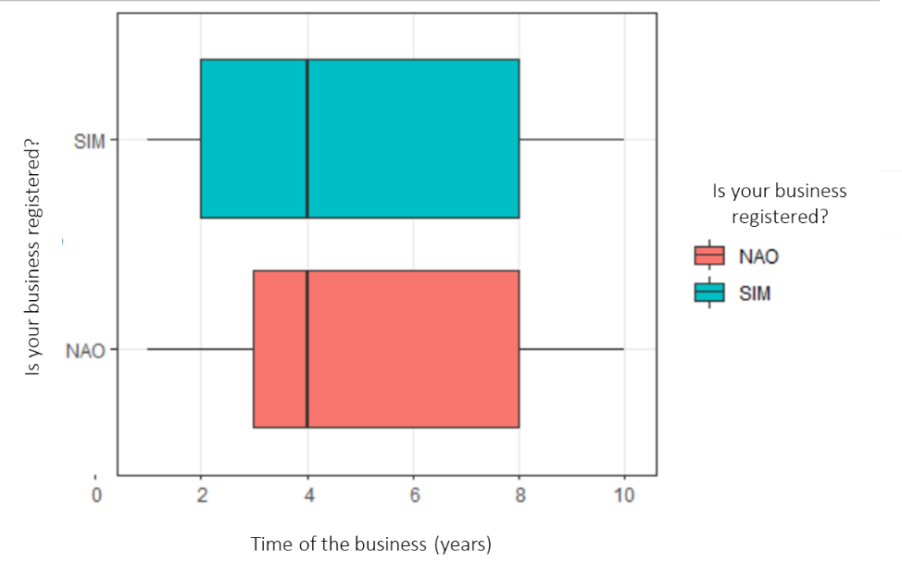

**Business time of existence and profit**

Different from the profile of candidates the growth of profit doesn’t seem to be linked with the years of existence. The businesses that made more than ten thousand meticais e the ones that made less than five thousand meticais have the same average of business time of existence. The business that made between five to ten thousand meticais of profit in the month prior to the registration in the Realiza Program have an average of five years of existence.

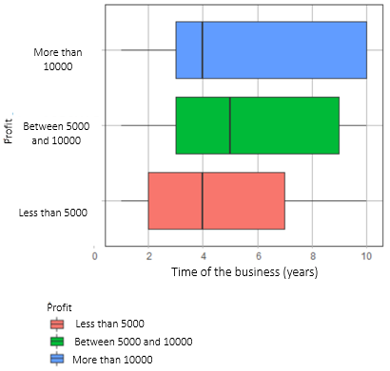

**Business sector**

The great majority of the business from the selected entrepreneurs are from the food sector. The city of Beira have 63% of the business from the food sector, Nampula have 55% and Maputo 40%. Business in the beauty sector are also quit frequent, the city of Beira 26% of the business in the area of beauty, similar to Maputo with 25% and Nampula with 24%.

As presented in the chart bellow the amount of “other” sector of business that are more frequent in the city of Maputo, with 33%, can be related to different types of services promoted by the entrepreneurs as accountability, events promotion, design, human resources services others.

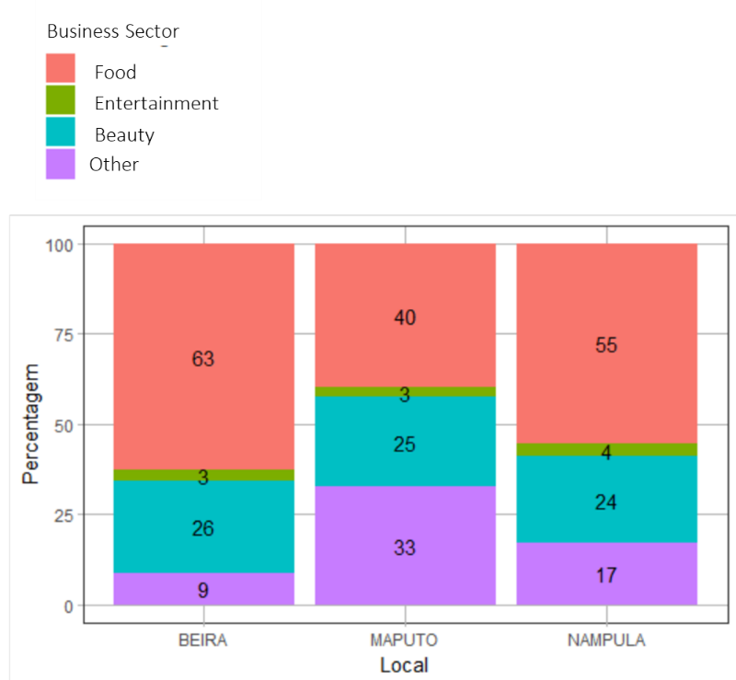

**Business Sector and Profit**

Based on the data collected with the selected entrepreneurs, the business sector cannot be related to the profit made. The business sectors of food, entertainment, beauty and others have similar have similar profit distributions.

In the chart below we can see that the food sector has 45% of entrepreneurs with less than five thousand and 25% with ten thousand of profit meticais. This fact could be explained by the variety of businesses in the sector, from full catering services, restaurants to the sale of selected and made-to-order items. The same can be truth for the beauty sector, with 42% of entrepreneurs that made less than five thousand but also 33% with more than ten thousand of profit, demonstrating a variety of profiles per sector, since businesses related to braiding hair at home to salons with structured physical space.

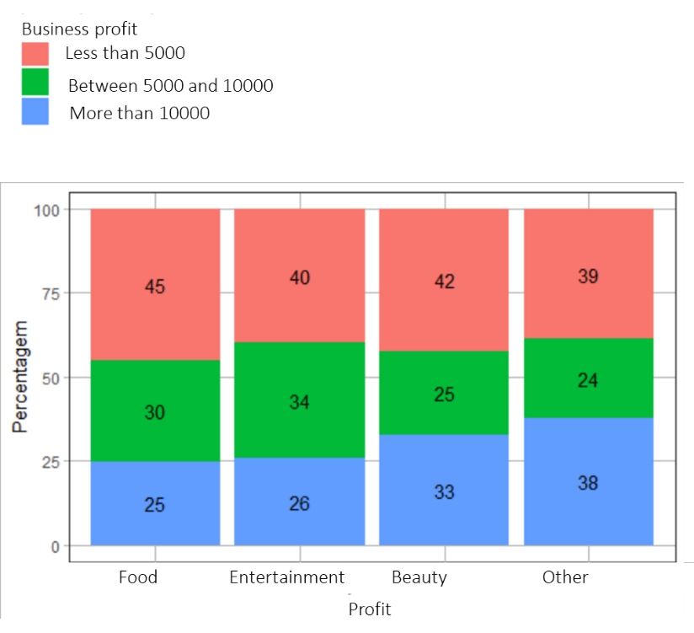

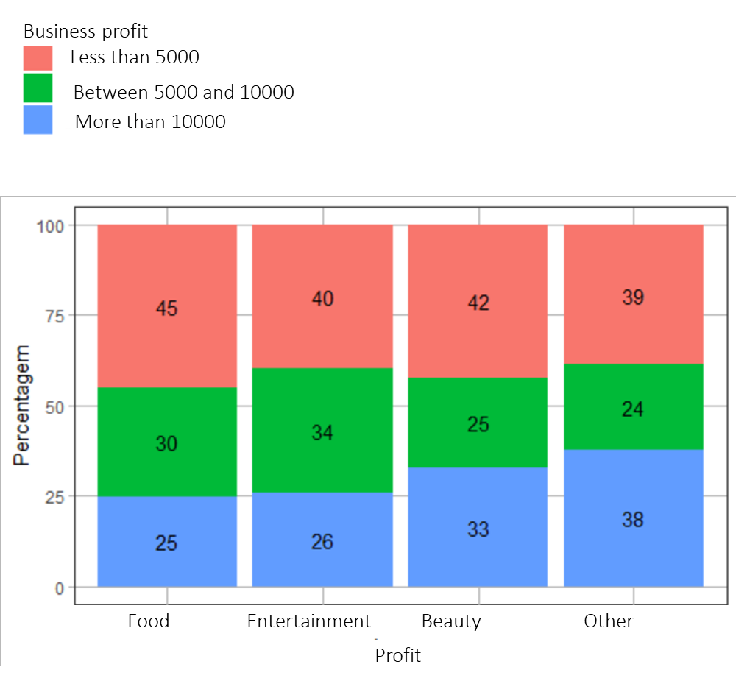

1. Candidates and selected entrepreneur’s

Mobilizadas

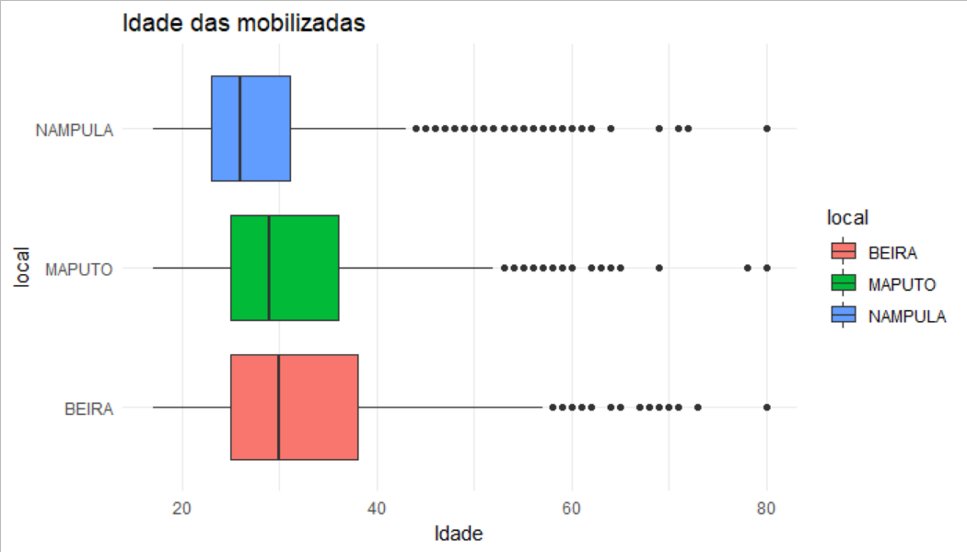

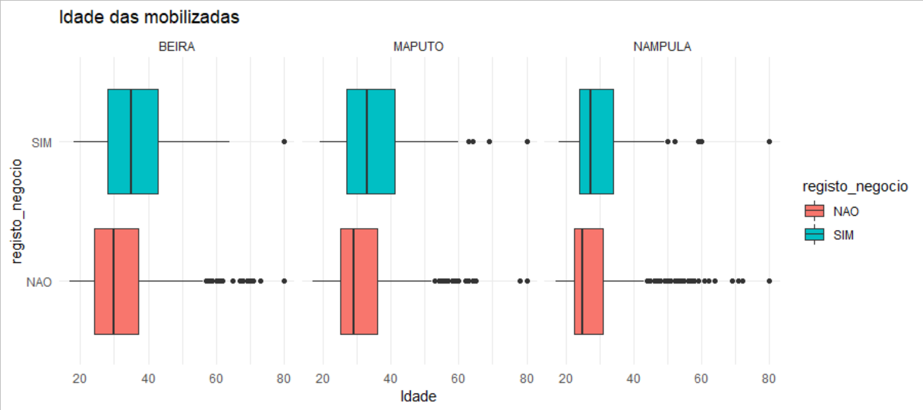

Selecionadas

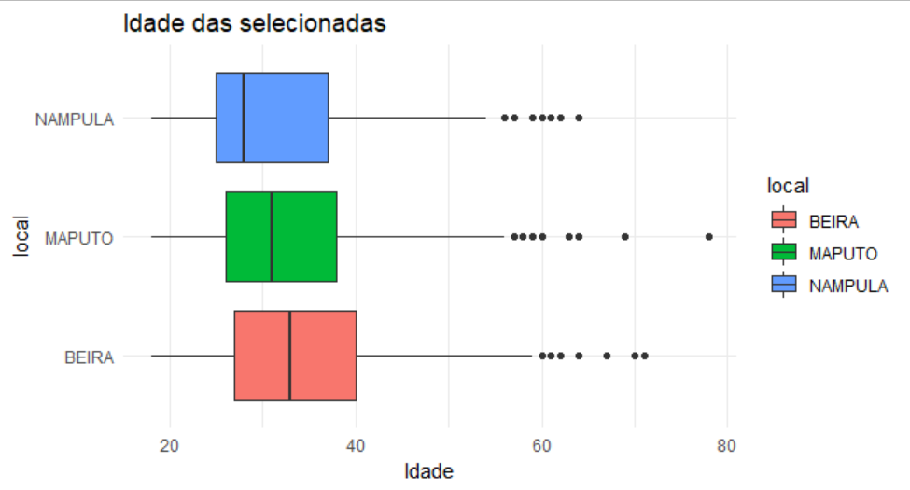

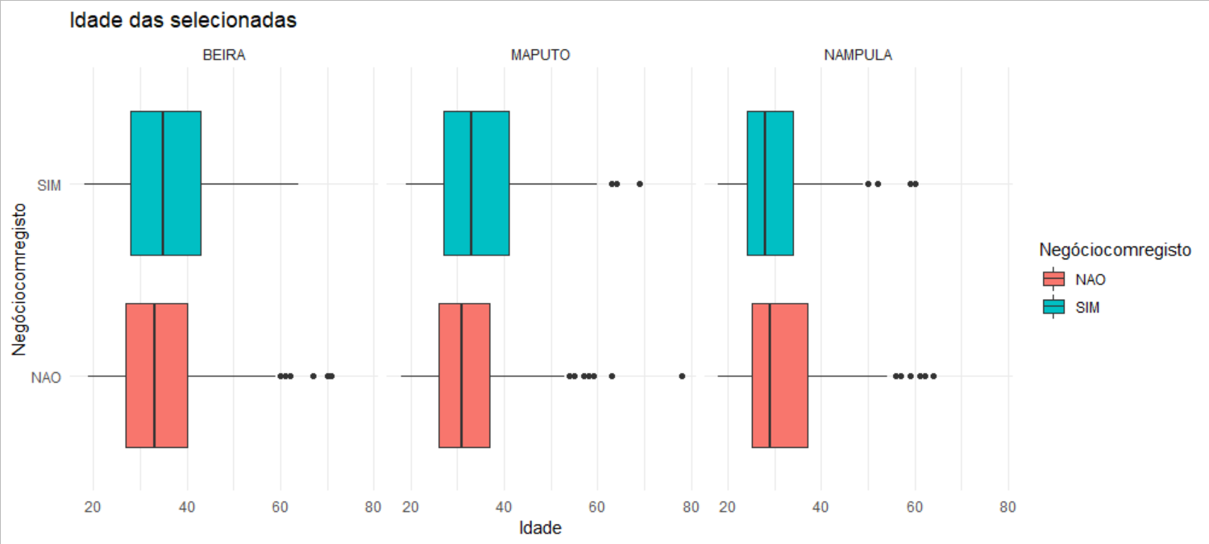

– Age

- Area/Neigborhood

1. Key strategic considerations for future mobilization